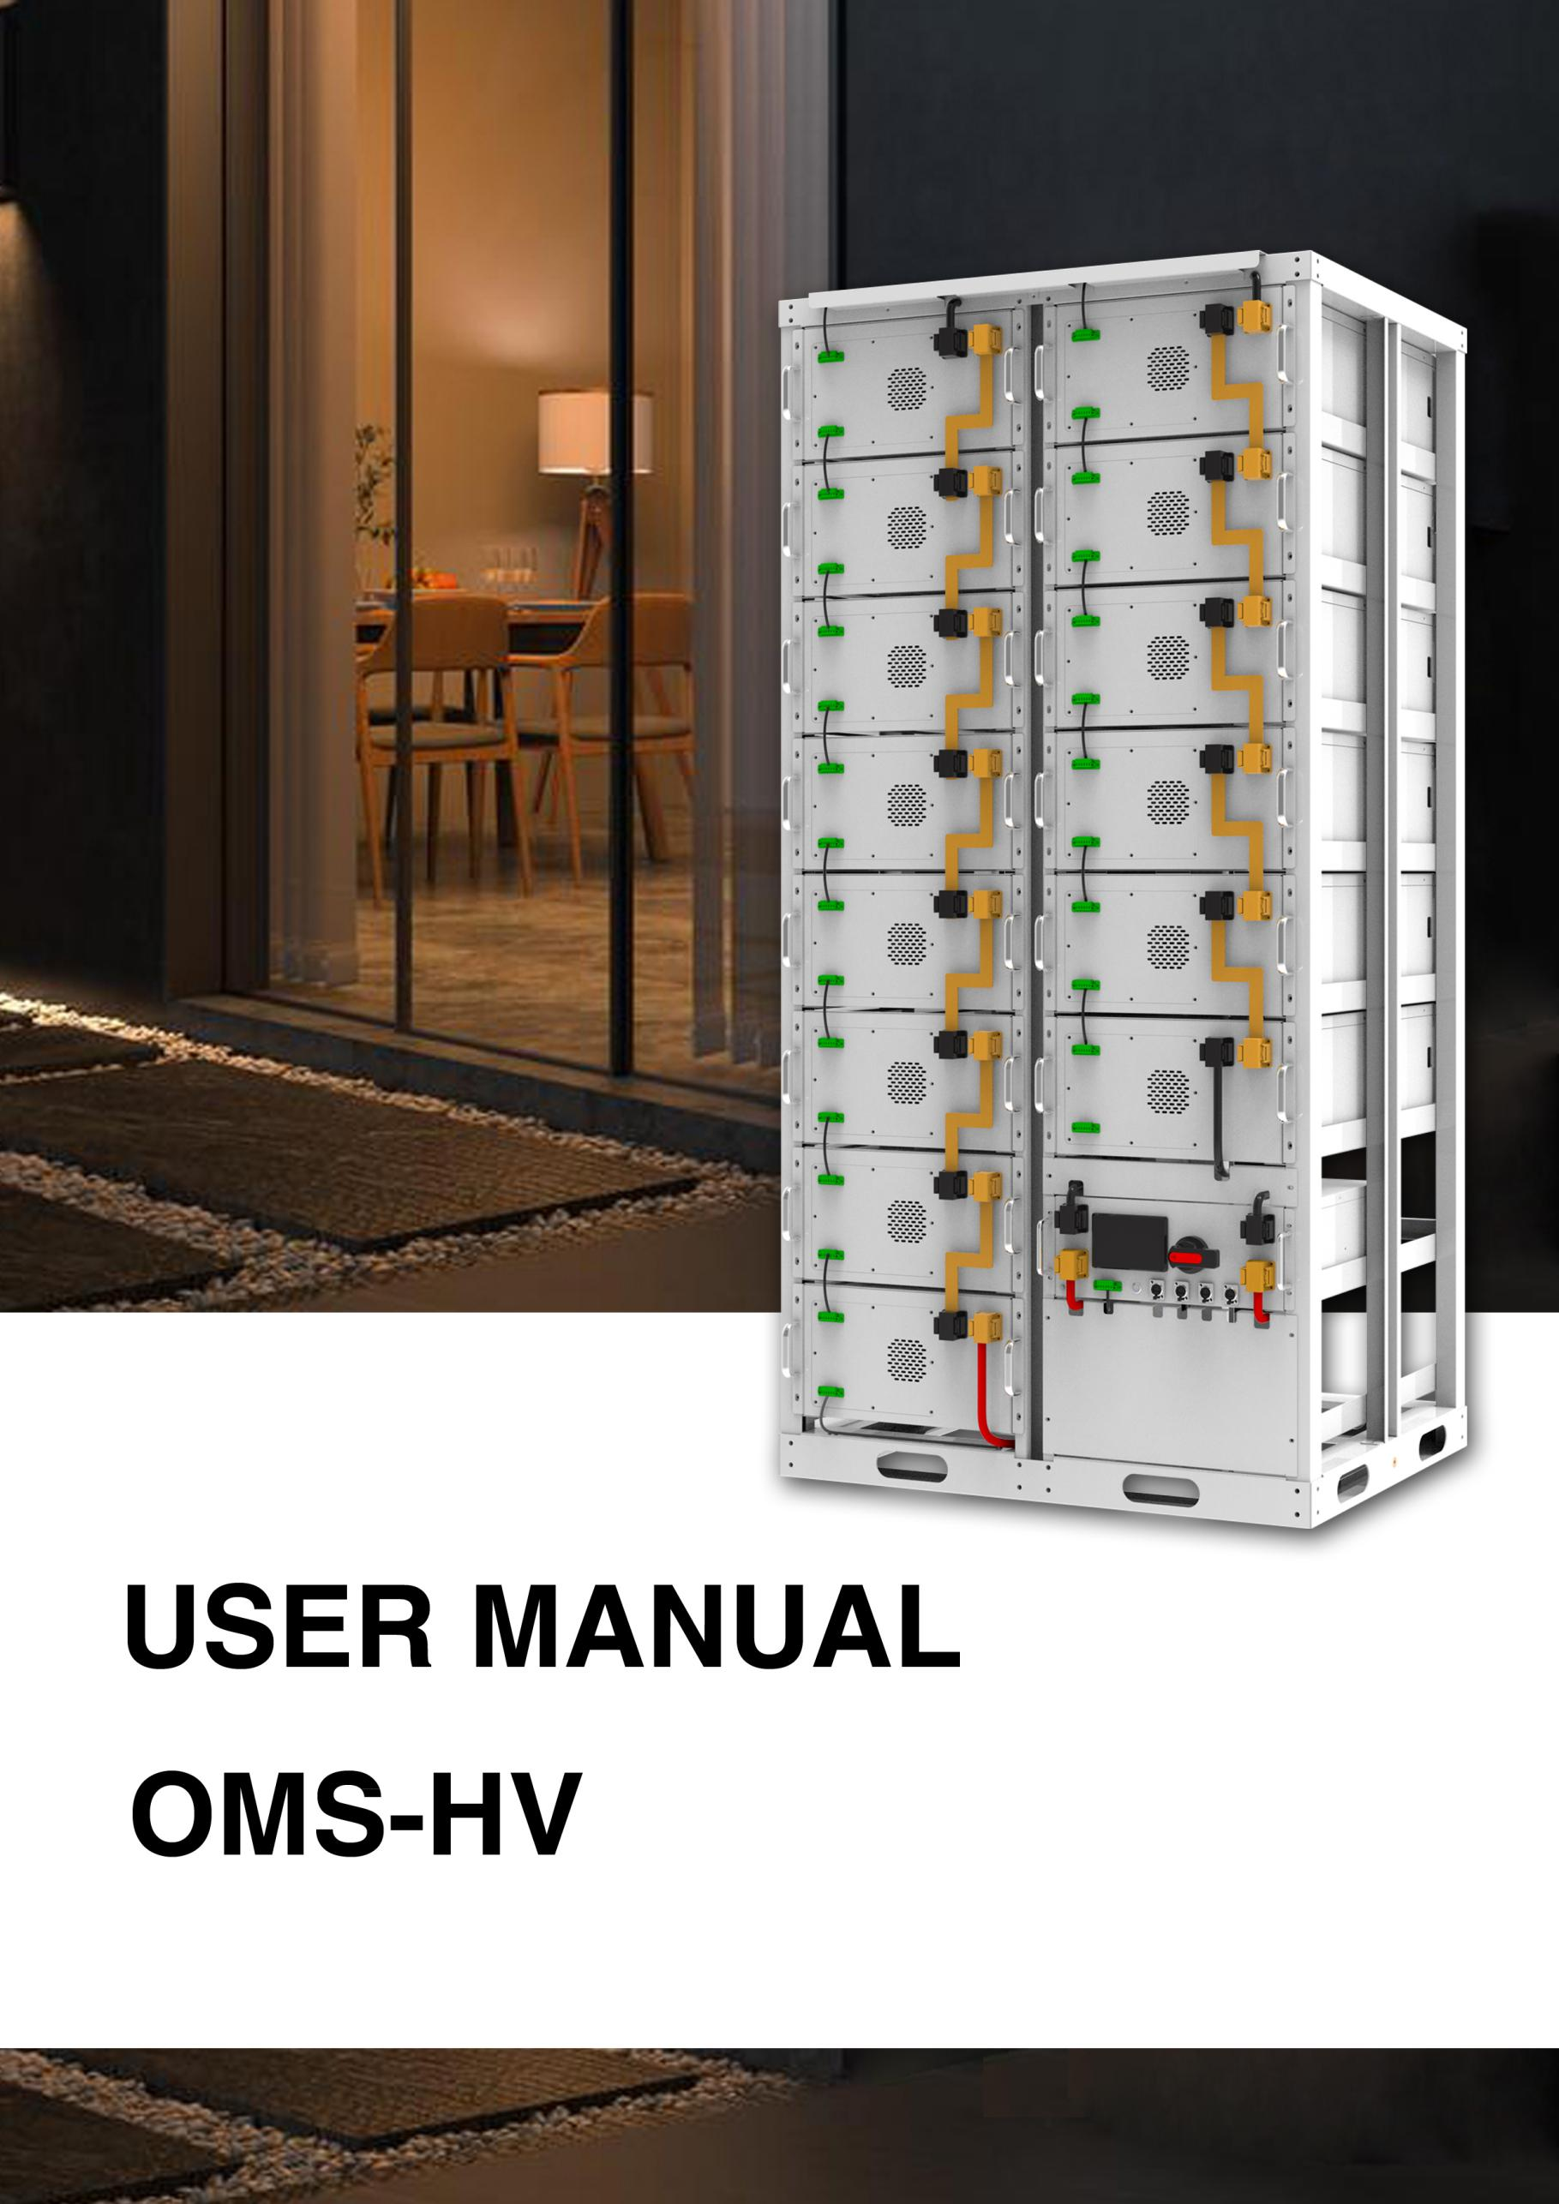
User Manual 280Ah

THANK YOU FOR USING THIS PRODUCT

1.Introduction

1.1、Important Safety Instructions
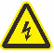
Danger!
Please do not put the battery into water or fire, in case of explosion or any other situation that might endanger your life.
Please connect wires properly while installation, do not reverse connect.
To avoid short circuit, please do not connect positive and negative poles with conductor on the same device.
Please avoid any form of damage to battery, especially stab, hit, trample or strike.

Danger!
Please shut off the power completely when removing the device or reconnecting wires during the daily use or it could cause the danger of electric shock.
Please use dry powder extinguisher to put out the flame when encountering a fire hazard, liquid extinguisher could result in the risk of explosion.
For your safety, please do not arbitrarily dismantle any component in any circumstances. The maintenance must be implemented by authorized technical personnel or our company’s technical support. Device breakdown due to unauthorized operation will not be covered under warranty.


Caution!
Our products have been strictly inspected before shipment. Please contact us if you find any abnormal phenomena such as device outer case bulging.
The product shall be grounded properly before use in order to ensure your safety.
To assure the proper use please make sure parameters among the relevant device are
compatible and matched.
Please do not mixed-use batteries from different manufacturers, different types and models, as well as old and new together.

Caution!
Ambient and storage method could impact the product life span, please comply with the operation environment instruction to ensure device works in proper condition.
For long-term storage, the battery should be recharged once every 6 months, and the amount of electric charge shall exceed 80% of the rated capacity.
Please charge the battery in 18 hours after it fully discharged or over-discharging protection mode is activated.
Formula of theoretical standby time: T=C/I (T is standby time, C is battery capacity, I is total current of all loads).

lithium iron phosphate battery system is a standard battery system unit, customers can choose a certain number of OM-51280 according to their needs, by connecting parallel to form a larger capacity battery pack, to meet the user's long-term power supply needs. The product is especially suitable for energy storage applications with high operating temperatures, limited installation space, long power backup time and long service life.

1.2、Product Properties
energy storage product’s positive electrode materials are lithium iron phosphate, battery cells are managed effectively by BMS with better performance, the system’s features as below:
The whole module is non-toxic, non-polluting and environmentally friendly;
Cathode material is made from LiFePO4 with safety performance and long cycle life.
Battery management system with better performance, possesses protection.function like over-discharge, over-charge, over-current, abnormal temperature.
Self-management on charging and discharging, Single core balancing function.
Intelligent design configures integrated inspection module.
Flexible configuration, multiple battery modules can be in parallel for expanding capacity and power.
Flexible configurations allow parallel of multi battery for longer standby time.
Self-ventilation with lower system noise.
Less battery self-discharge, then recharging period can be up to 10 months during the storage.
No memory effect so that battery can be charged and discharged shallowly.
With wide range of temperature for working environment, -20℃ ~ +55℃, circulation span and discharging performance are well under high temperature.
Small size and light weight, standard of 19-inch embedded designed module is comfortable for installation and maintenance;
- Product Specification

2.1 Performance Parameter
Table 2-2 performance parameter
Basic Parameters | OMS-51.2*N-280AH
Nominal Voltage (V) | 51.2*N
Nominal Capacity (KWH) | 14.3*N
Usable Capacity (KWH) | 14.3*N*90%
Battery Controller Name | BSMC-1000-120
Battery Module Name | 51280Ah
Battery Module Quantity | N
Battery Module Capacity(KWH) | 14.3
Battery Module Voltage(V dc) | 51.2
Battery Module Capacity (Ah) | 280
Battery System Charge Voltage(V dc) | 56*N
Battery System Charge Current(Normal) | 50
Battery System Charge Current（Max） | 140
Battery System Discharge lower-Voltage(Vdc) | 48*N
Battery System Discharge Current (Standard) | 140
Battery System Discharge Current(Normal) | 140
Efficiency | 96%
Depth of Discharge | RS485/RS232/CAN
Working Temperature | 0℃~50℃ Charge  -10℃ ~50℃ Disharge
Shelf Temperature | -20℃~60℃
Communicaiton | RS485/CAN
Certification | CE/IEC/UL/UN38.3/MSDS
Design Life | 10 years+
Cycle Life | >6000
Other:  - Battery Controller Dimensions (W*D*H)  - Battery Module Dimensions(W*D*H) | 483*245*792

2.2 Battery Module

2.2.1 Battery Module Information

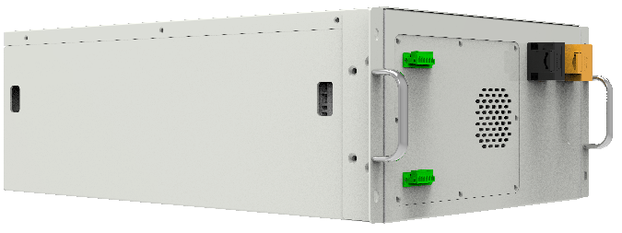

No. | Product Type | OMS51280
1 | Cell Technology | Li-ion(LFP)
2 | Battery Module Capacity (KWH) | 14.3
3 | Battery Module Voltage (Vdc) | 51.2
5 | Battery Cell Voltage（Vdc） | 3.2
6 | Battery Cell Capacity (AH) | 280
7 | Battery Module Cell Quantity in Series(pcs) | 16
8 | Battery Module Charge Voltage(Vdc) | 57.6
9 | Battery System Charge Current(Standard) | 100
10 | Battery Module Charge Current(Normal) | 140
11 | Battery Module Charge Current(Max) | 140
12 | Battery Module Discharge Lower-Voltage(Vdc) | 44.8
13 | Battery System Discharge Current (Standard) | 100
14 | Battery Module Charge Current (Normal) | 140
15 | Battery Module Charge Current (Max) | 280
16 | Efficiency | 98%
17 | Depth of Discharge | 90%
18 | Dimension(W*D*H, mm) | 483*245*792
19 | Communication | RS485
20 | Protection Class | IP22
21 | Weight | 98
22 | Operation Life | >10 years
23 | Operation Cycle Life | >6000
24 | Operation Temperature | 0℃~50℃ Charge  -10℃ ~50℃ Disharge
25 | Storage Temperature | -20℃~60℃
26 | Product Certificate | CE/IEC/UL
27 | Transfer Certificate | UN38.3/MSDS

2.2.2 Battery Module Front Interface

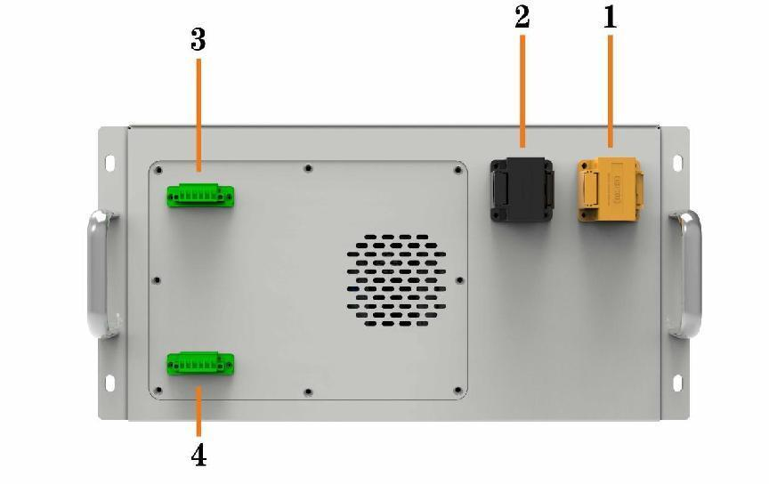

Table 2-3 Interface Definition
Item | Name | Definition
1 | Positive socket | Battery output positive or parallel positive line
2 | Negative socket | Battery output positive or parallel positive line
3 | Communication Port IN | Support RS485 communication between battery module, and control module
4 | Communication Port OUT | Support RS485 communication between battery module, and control module

2.3 Control Module (internal power supply)
2.3.1 Control Module information

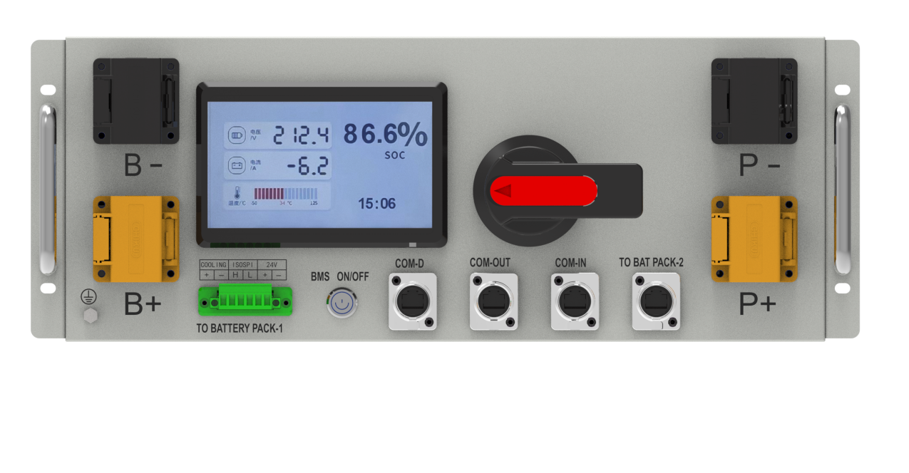
Item | Basic Parameters
 | Related Product | 1000V 140A
1 | AC supply | --
2 | System Operation Voltage (Vdc) | 0-1000V
3 | Nominal Current(A) | 140
4 | Self-consumption Power(W) | 8
5 | Dimension (W* D* H, mm) | 450*460*177
6 | Communication | RS485/CAN
7 | Protection Class | IP20
8 | Weight(KGS) | 20
9 | Operation Life | 10+
10 | Operation Temperature | -20~65
12 | Storage Temperature | -40~80

2.3.2 High Voltage Control Module

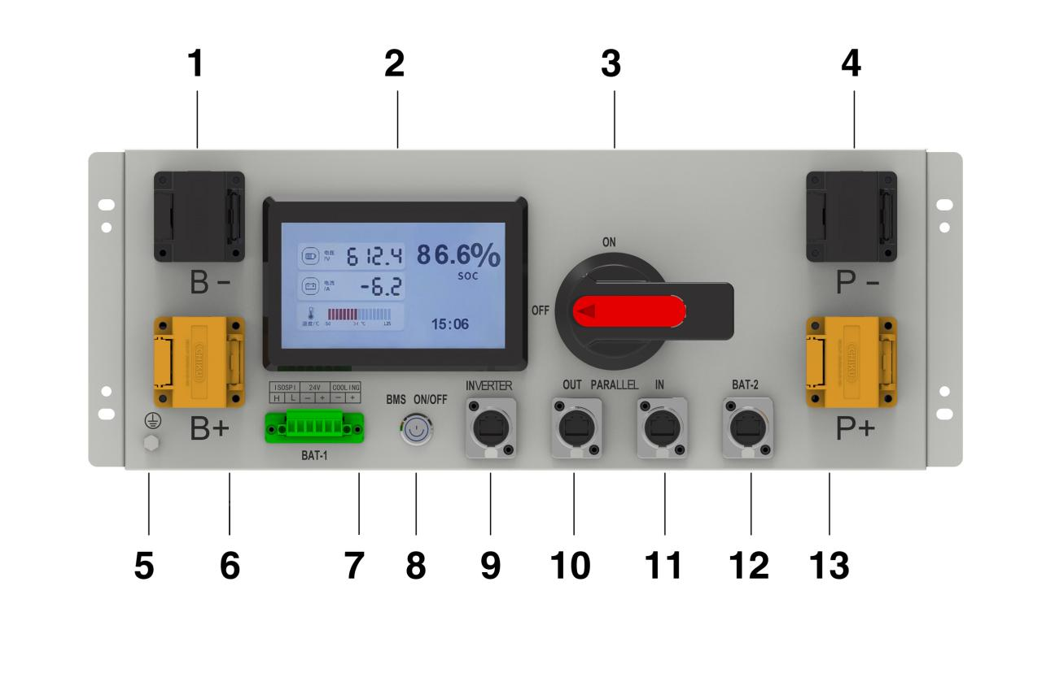
Table 2-3 Interface Definition
Item | Name | Definition
1 | Battery Access Negative | Battery Pack Negative Connector
2 | Display screen | Display battery pack information
3 | Power switch | OFF/ON,  must be in the "ON" state when in use
4 | DC Output Negative | Connect the inverter DC negative terminal
5 | Grounding wire | Ground connection
6 | Battery Input Positive | Battery pack positive access
7 | Communication interface | Connection to Battery Pack Communication
8 | BMS Switch | Switch BMS on/off
9 | Communication port | Connect to inverter
10 | Parallelism | Battery Cluster Parallel Network Port
11 | Parallelism | Battery Cluster Parallel Network Port
12 | Communication interface | Connection to Battery Pack Communication
13 | DC Output Positive | Connect the DC positive terminal of the inverter

- Installation and Configuration

3.1 Preparation for installation

3.1.1 Safety Requirement
This system can only be installed by personnel who have been trained in the power supply
system and have sufficient knowledge of the power system.
The safety regulations and local safety regulations listed below should always be followed during
the installation.
● All circuits connected to this power system with an external voltage of less than 51.2V
must meet the SELV requirements defined in the IEC60950 standard.
● If operating within the power system cabinet, make sure the power system is not
charged. Battery devices should also be switched off.
● Distribution cable wiring should be reasonable and has the protective measures to avoid
touching these cables while operating power equipment.
● when installing the battery system, must wear the protective items below:
 | 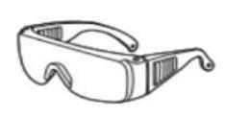 | 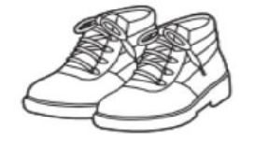
The isolation gloves | Safety goggles | Safety shoes

3.1.2 Environmental requirements
Working temperature: -20℃ ~ +55℃
Charging temperature range is 0oC~+55℃,
Discharging temperature range is -20℃ ~+55℃
Storage temperature: -10℃~ +35℃
Relative humidity: 5% ~ 85%RH
Elevation: no more than 4000m
Operating environment: Indoor installation, sites avoid the sun and no wind, no conductive
dust and corrosive gas.
And the following conditions are met:
• Installation location should be away from the sea to avoid brine and high humidity
environment.
• The ground for product arrangement shall be flat and level.
• No flammable explosive materials near the installation site.
• The optimal ambient temperature is 15℃~ 30℃
• Keep away from dust and messy zones

3.1.3 Tools and data
Tools and meters that may be used are shown in table 3-1.
Table 3-1 Tool instrument
NAME
Screwdriver（Slotted、Phillips） | Multimeter
Torque wrench | Clamp current meter
Diagonal pliers | Insulation tape
Pointed nose pliers | Temperature meter
Pliers to hold the wire | Anti-static bracelet
Stripping pliers | Cable tie
Electric drill | Tape measure

3.1.4 Technical preparation
Electrical interface check
Devices that can be connected directly to the battery can be user equipment, power supplies,
or other power supplies.
● Confirm whether the user's PV power generation equipment, power supply or other
power supply equipment has a DC output interface, and measure whether the DC power
output voltage meets the voltage range requirements in Table 2-2.
● Confirm that the maximum discharge current capability of the DC power interface of the
user's photovoltaic power generation equipment, power supply or other power supply
equipment should be higher than the maximum charging current of the products used in
Table 2-2.
If the maximum discharge capacity of the DC power interface of the user's photovoltaic
power generation equipment is less than the maximum charging current of the products
used in Table 2-2, the DC power interface of the user's photovoltaic power generation
equipment shall have a current limiting function to ensure the normal operation of the
user’s equipment.
● Verify that the maximum operating current of the battery-powered user equipment
(inverter DC input) should be less than the maximum discharge current of the products
used in Table 2-2.

The security check
● Firefighting equipment should be provided near the product, such as portable dry
powder fire extinguisher.
● Automatic fire fighting system shall be provided for the case where necessary.
● No flammable, explosive and other dangerous materials are placed beside the battery.

3.1.5 Unpacking inspection
● When the equipment arrives at the installation site, loading and unloading should
be carried out according to the rules and regulations, to prevent from being exposed to
sun and rain.
● Before unpacking, the total number of packages shall be indicated according to the
shipping list attached to each package, and the case shall be checked for good condition.
● In the process of unpacking, handle with care and protect the surface coating of the
object.

3.2 Equipment installation

3.2.1 Installation Steps
Step 1 Mechanical Installation
(1) Brackets installation:
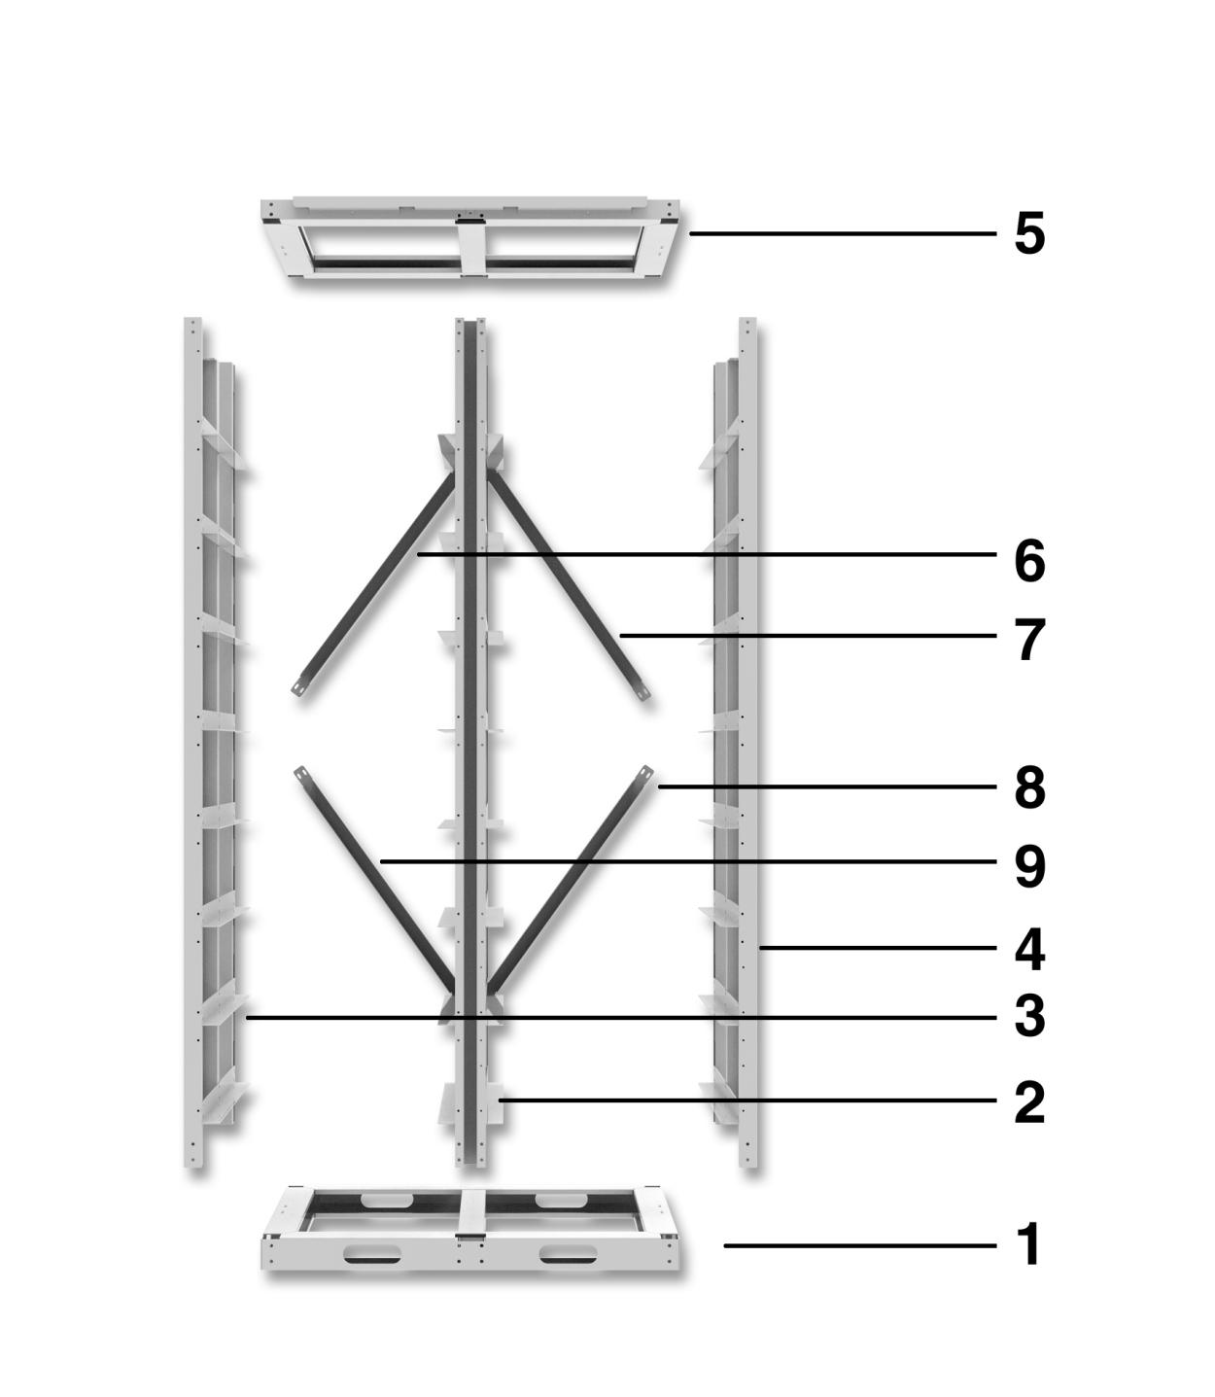

Assembling in order

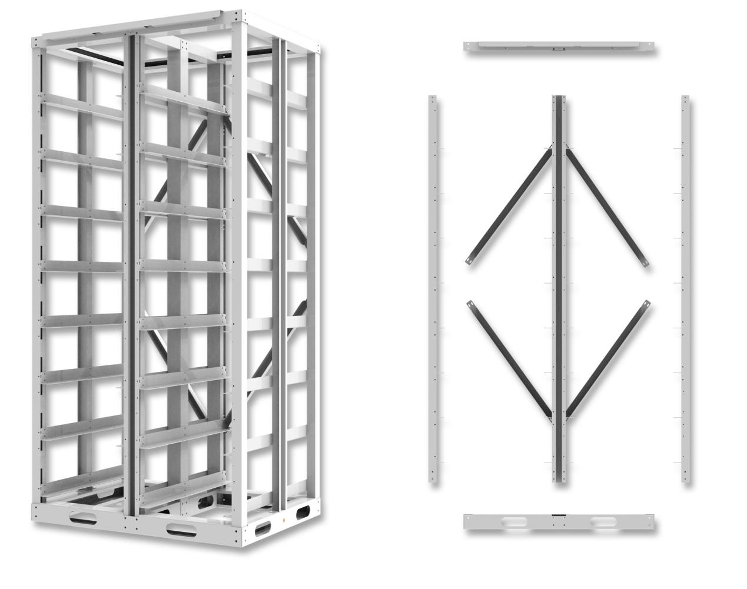

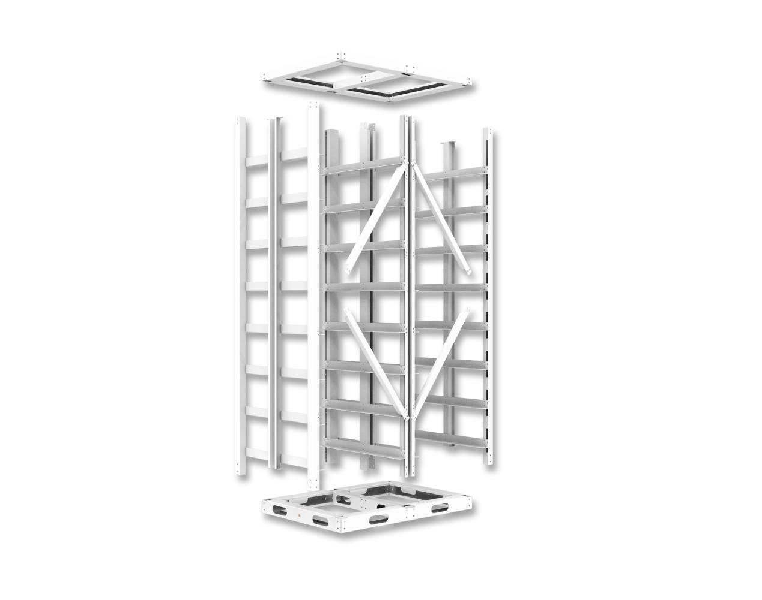
Step 2 Electrical installation
- Connect with inverter
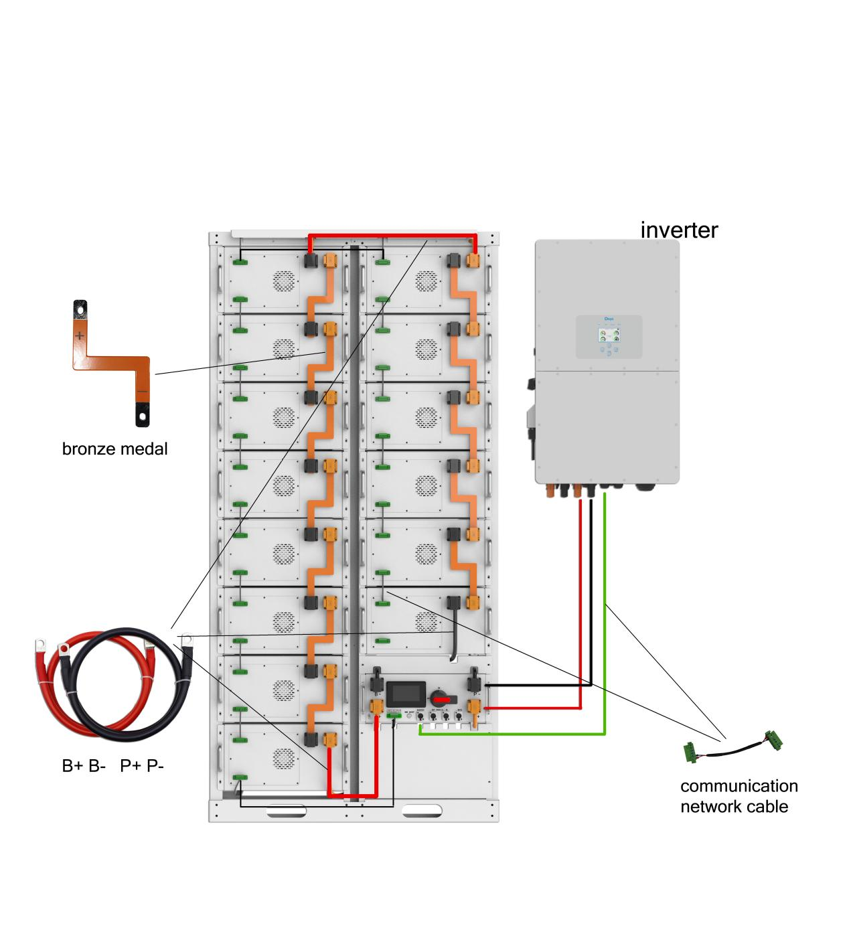

3.2.2 Battery parameter settings on the inverter
If your inverter do not have communication function with BSM48106 battery pack, please set inverter follow next data.

Max Charging(Bulk) Voltage: 57*N V
Absorption Voltage: 56.5*N V
Float Voltage: 56*N V
Shut Down(cut off) Voltage: 49*N V
Shut Down(cut off) SOC: 20%
Restart Voltage: 51.2*N V
Max Charge Current: 280A*battery QTY
Max Discharge Current:280A*battery QTY



This manual is for reference only, if the technology is better, please contact the distributor or our company.

