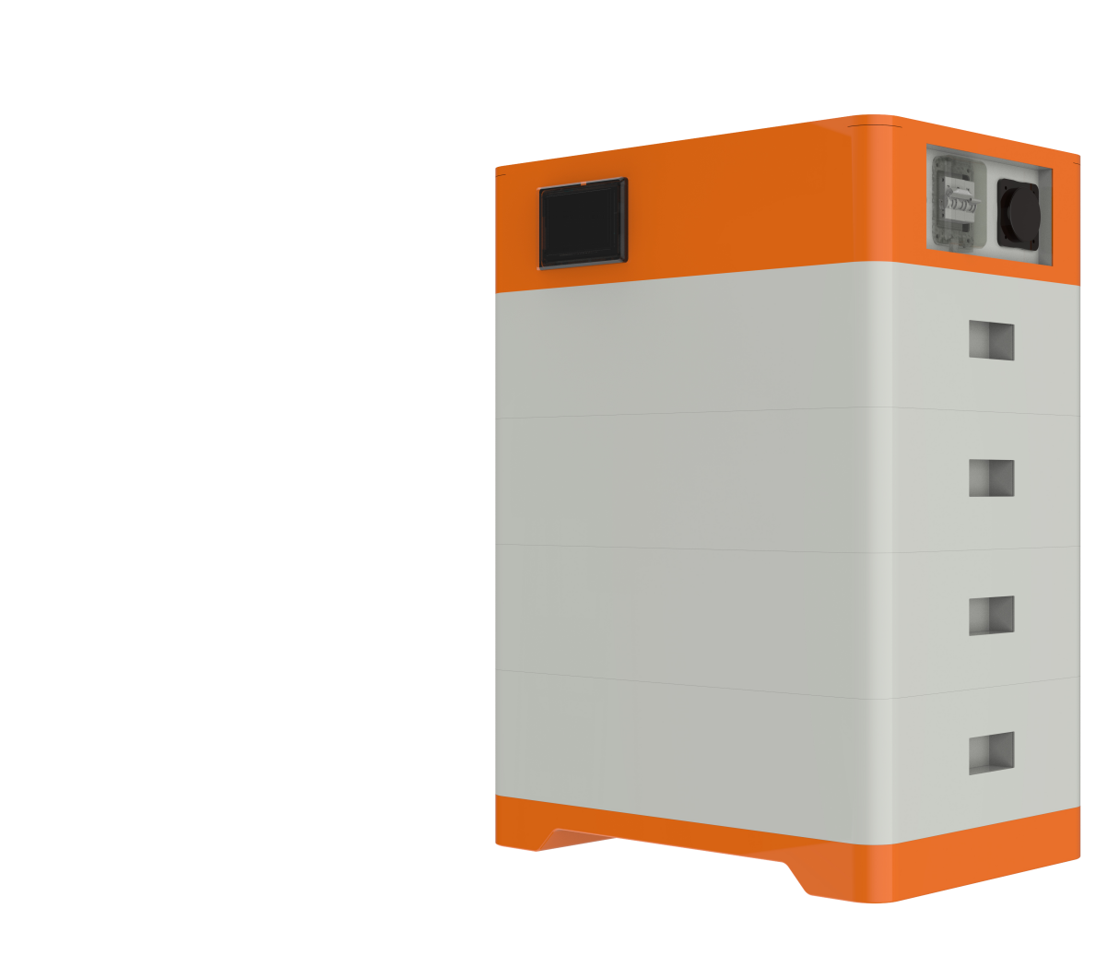

OMS-HV
User Manual

Content

1.Introduction 1
1.1、Important Safety Instructions 1
1.2、Product Properties 2
2.Product Specification 3
2.1、Size and Weight 3
2.2、Performance Parameter 4
2.3 Equipment Interface Instruction 4
2.3.1 、CAN/485/RS232 interface definition 6
2.3.2 Display 7
2.4 Battery Management System(BMS) 7
2.4.1 、BMS Protection and Alarm 7
3.Installation and Configuration 8
3.1、Preparation for installation 8
3.1.1、 Safety Requirement 8
3.1.2 Environmental requirements 9
3.1.3 Tools and data 10
3.1.4 Technical preparation 10
3.1.5 Unpacking inspection 10
3.2.Equipment installation 11
3.2.1、Installation Steps 11
3.2.2 Battery parameter settings on the inverter 13
4.Installation and Configuration 13
4.2、Alarm description and processing 14

1.Introduction

1.1、Important Safety Instructions
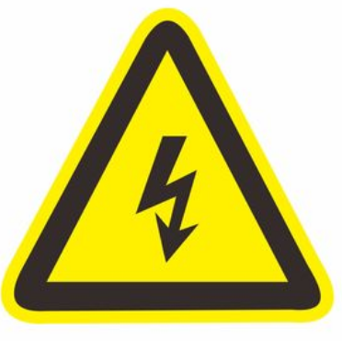
Danger!
Please do not put the battery into water or fire, in case of explosion or any other situation that might endanger your life.
Please connect wires properly while installation, do not reverse connect.
To avoid short circuit, please do not connect positive and negative poles with conductor on the same device.
Please avoid any form of damage to battery, especially stab, hit, trample or strike.

Danger!
Please shut off the power completely when removing the device or reconnecting wires during the daily use or it could cause the danger of electric shock.
Please use dry powder extinguisher to put out the flame when encountering a fire hazard, liquid extinguisher could result in the risk of explosion.
For your safety, please do not arbitrarily dismantle any component in any circumstances. The maintenance must be implemented by authorized technical personnel or our company’s technical support. Device breakdown due to unauthorized operation will not be covered under warranty.


Caution!
Our products have been strictly inspected before shipment. Please contact us if you find any abnormal phenomena such as device outer case bulging.
The product shall be grounded properly before use in order to ensure your safety.
To assure the proper use please make sure parameters among the relevant device are
compatible and matched.
Please do not mixed-use batteries from different manufacturers, different types and models, as well as old and new together.

Caution!
Ambient and storage method could impact the product life span, please comply with the operation environment instruction to ensure device works in proper condition.
For long-term storage, the battery should be recharged once every 6 months, and the amount of electric charge shall exceed 80% of the rated capacity.
Please charge the battery in 18 hours after it fully discharged or over-discharging protection mode is activated.
Formula of theoretical standby time: T=C/I (T is standby time, C is battery capacity, I is total current of all loads).

OMS-51100 lithium iron phosphate battery system is a standard battery system unit, customers can choose a certain number of OMS-51100 according to their needs, by connecting parallel to form a larger capacity battery pack, to meet the user's long-term power supply needs. The product is especially suitable for energy storage applications with high operating temperatures, limited installation space, long power backup time and long service life.

1.2、Product Properties

MSO51100 energy storage product’s positive electrode materials are lithium iron phosphate, battery cells are managed effectively by BMS with better performance, the system’s features as below:
The whole module is non-toxic, non-polluting and environmentally friendly;
Cathode material is made from LiFePO4 with safety performance and long cycle life.
Battery management system with better performance, possesses protection.function like over-discharge, over-charge, over-current, abnormal temperature.
Self-management on charging and discharging, Single core balancing function.
Intelligent design configures integrated inspection module.
Flexible configuration, multiple battery modules can be in parallel for expanding capacity and power.
Flexible configurations allow parallel of multi battery for longer standby time.
Self-ventilation with lower system noise.
Less battery self-discharge, then recharging period can be up to 10 months during the storage.
No memory effect so that battery can be charged and discharged shallowly.
With wide range of temperature for working environment, -20℃ ~ +55℃, circulation span and discharging performance are well under high temperature.
Small size and light weight, standard of 19-inch embedded designed module is comfortable for installation and maintenance;

2.Product Specification

2.1、Size and Weight
Module Module Cluster

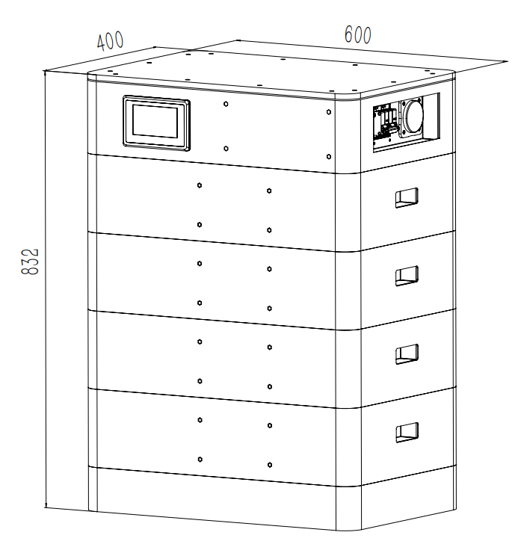
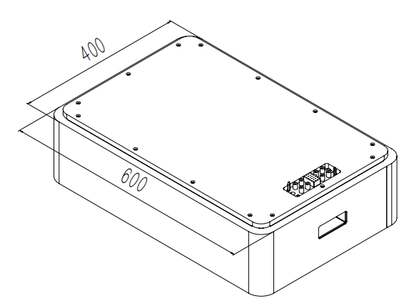

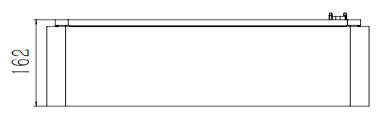

High voltage control Box Module

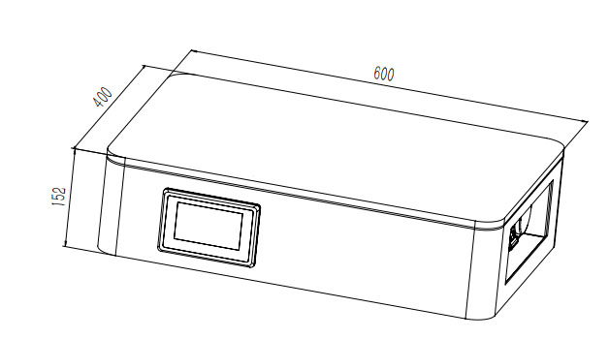

Table 2-1
Product | Nominal  Voltage | Nominal  Capacity | Dimension | Weight
OMS48105HP*2 | 102.4V | 100/106 | 600*400*534 | 125
OMS48105HP*3 | 153.6V | 100/106 | 600*400*683 | 170
OMS48105HP*4 | 204.8V | 100/106 | 600*400*832 | 215
OMS48105HP*5 | 256V | 100/106 | 600*400*981 | 260
OMS48105HP*6 | 307.2V | 100/106 | 600*400*1130 | 305
OMS48105HP*7 | 358.4V | 100/106 | 600*400*1279 | 350
OMS48105HP*8 | 409.6V | 100/106 | 600*400*1428 | 395

2.2、Performance Parameter
Table 2-2 performance parameter
Basic Parameters | OMS48105HP |  | OMS48105HP*2 | OMS48105HP*3 |  | OMS48105HP*4 |  | OMS48105HP*5 |  | OMS48105HP*6 |  | OMS48105HP*7 |  | OMS48105HP*8
Nominal Voltage (V) | 51.2V |  | 104.6V | 153.6 |  | 204.8 |  | 256 |  | 307.2 |  | 358.4 |  | 409.6
Nominal Capacity (KWH) | 5376*N
Usable Capacity (KWH) | 4838*N
Discharge Voltage (V) | 40V | 80V |  |  | 120V |  | 160V |  | 200V |  | 240V |  | 280V |  | 320V
Charge Voltage (V) | 58.4V | 116.8V |  |  | 175.2V |  | 233.6V |  | 292V |  | 350.4V |  | 408.8V |  |  | 467.2V
Recommend Charge/Discharge Current (A) | 100
Max.Charge/Discharge Current(A) | 100
Peak Charge/Discharge Current(A) | 120(15S)
Communicaiton | RS485/RS232/CAN
Working Temperature | 0℃~50℃ Charge -10℃ ~50℃ Disharge
Shelf Temperature | -20℃~60℃
Certification | CE/IEC/UL/UN38.3/MSDS
Design Life | 10 years+
Cycle Life | >6000

2.3 Equipment Interface Instruction
This section details the front and back interface functions of the pack
Product Front Interface
1
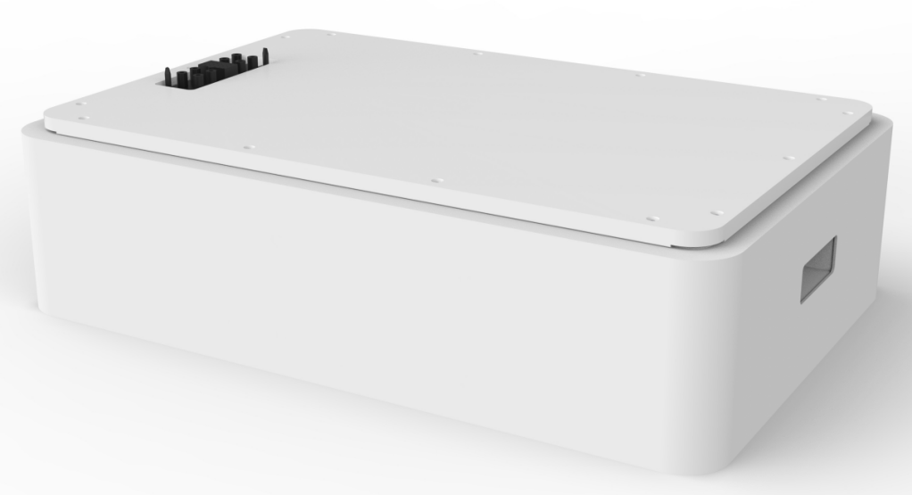

Control Box Module Front Interface
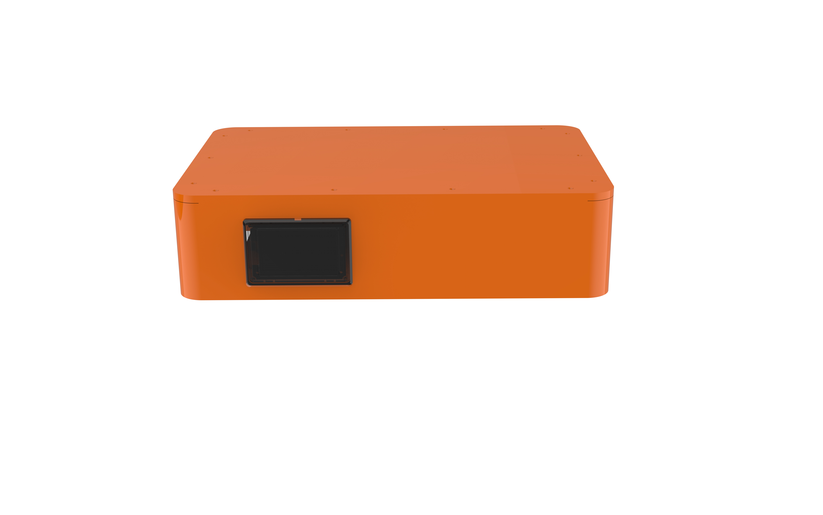

2

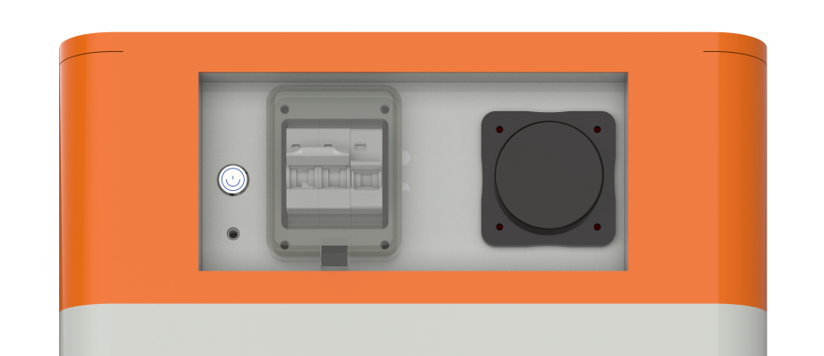

4
3
65
5

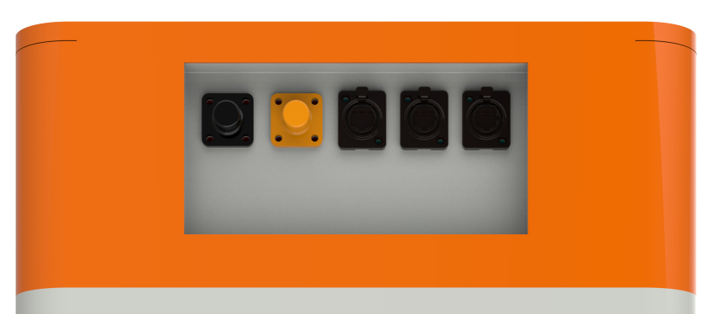

7 8 9 10

Table 2-3 Interface Definition
Item | Name | Definition
1 | Power Connector | For battery pack connect in parallel
2 | Screen | Show battery information
3 | Air Switch | Current Protection
4 | BMS ON/OFF | Start BMS
5 | Ground Point | Ground Point
6 | WiFi | WiFi
7 | Positive Output | DC + To Inverter
8 | Negative Output | DC - To Inverter
9 | Communication Port | Communication to inverter
10 | Communication Port | Communication between battery cluster

2.3.1 、CAN/485/RS232 interface definition

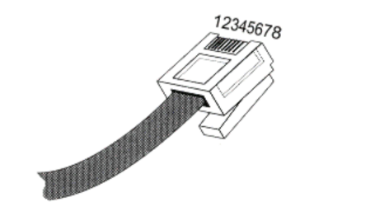
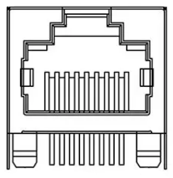

RS485/CAN | RS485/CAN
Communication to inverter | Communication between battery cluster

 | PIN position | Color | Definition
RS485/CAN | PIN1 | Orange/White | 485B1
RS485/CAN | PIN2 | Orange | 485A1
RS485/CAN | PIN3 | Green/White | GND
RS485/CAN | PIN4 | Blue | CANH
RS485/CAN | PIN5 | Blue/White | CANL
RS485/CAN | PIN6 | Green | GND
RS485/CAN | PIN7 | Brown/White | 485A2
RS485/CAN | PIN8 | Brown | 485B2

2.3.2 Display
1 5

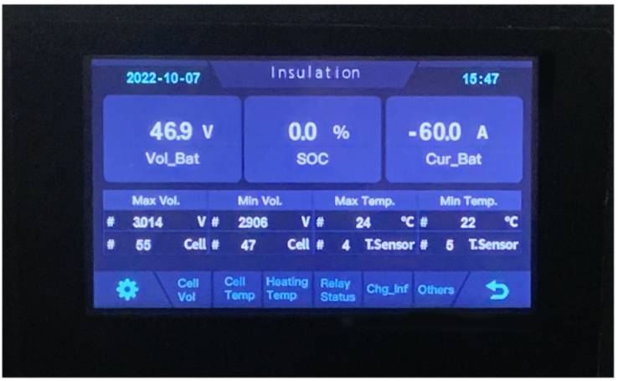

2
4

3

NO. | Description | Function
1 | SOC | Display real-time SOC value of energy storage system
2 | Voltage | Display real-time voltage
3 | Temperature | Display battery highest temperature
4 | Current | Display battery real-time temperature
5 | System status | READY means normal operation, ALM means system failure

2.4 Battery Management System(BMS)

2.4.1 、BMS Protection and Alarm

Over Voltage Alarm/Protection in Charging:
When total voltage or any battery cell voltage reaches the rated
alarm value during charging stage, the alarm light will flash. When reaches the rated protection value, the alarm light will on, battery will stop charge. After total voltage or all cell voltage back to rated range, the protection is over

Low Voltage Protection in Discharging:
Battery system will stop supply power to the outside, when any battery cell voltage or total voltage is lower than the rated protection value during discharging, the over-discharging protection is activated. When the voltage of each cell back to rated return range, the protection is over.

Over Current Protection in Charging:
When the charge current ＞ 100A, current limit protection mode is activated, current will be limited to 10A，protection is removed after rated time delaying 10S. Circulate like this until the current is lower than 100A.

Over Current Protection in Discharging：
When the discharge current is higher than 100A, the battery buzzer alarms and the system stops discharging after 15s. After protection, the discharging will restore in 60s delay or immediately when there is charging current.

Low/Over temperature protection in charging：
When battery’s temperature is beyond range of -5 ℃ ~+55 ℃ during charging, temperature protection is activated, device stops charging.
The protection is over when temperature back to rated working range.

Low/Over temperature protection in discharging：
When battery’s temperature is beyond range of -20℃~+55℃ during discharging, temperature protection is activated, device stops supplying power to the outside.
The protection is over when temperature back to rated working range.

Short Circuit Protection：
When the battery is activated from the shutdown state, if a short circuit occurs, the system starts short-circuit protection for 60 seconds.

Self-Shutdown：
When device connects no external loads and power supply and no external communication for over 72 hours, device will dormant standby automatically.

3.Installation and Configuration

3.1、Preparation for installation

3.1.1、 Safety Requirement
This system can only be installed by personnel who have been trained in the power supply system and have sufficient knowledge of the power system.
The safety regulations and local safety regulations listed below should always be followed during the installation.
● All circuits connected to this power system with an external voltage of less than 51.2V
must meet the SELV requirements defined in the IEC60950 standard.
● If operating within the power system cabinet, make sure the power system is not
charged. Battery devices should also be switched off.
● Distribution cable wiring should be reasonable and has the protective measures to avoid
touching these cables while operating power equipment.
● when installing the battery system, must wear the protective items below:
 | 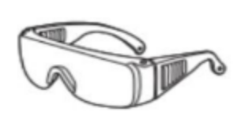 | 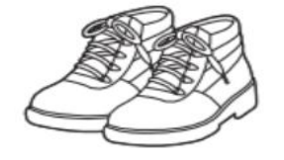
The isolation gloves | Safety goggles | Safety shoes

3.1.2 Environmental requirements
Working temperature: -20℃ ~ +55℃
Charging temperature range is 0oC~+55℃,
Discharging temperature range is -20℃ ~+55℃
Storage temperature: -10℃~ +35℃
Relative humidity: 5% ~ 85%RH
Elevation: no more than 4000m
Operating environment: Indoor installation, sites avoid the sun and no wind, no conductive
dust and corrosive gas.
And the following conditions are met:
• Installation location should be away from the sea to avoid brine and high humidity
environment.
• The ground for product arrangement shall be flat and level.
• No flammable explosive materials near the installation site.
• The optimal ambient temperature is 15℃~ 30℃
• Keep away from dust and messy zones

3.1.3 Tools and data
Tools and meters that may be used are shown in table 3-1.
Table 3-1 Tool instrument
NAME
Screwdriver（Slotted、Phillips） | Multimeter
Torque wrench | Clamp current meter
Diagonal pliers | Insulation tape
Pointed nose pliers | Temperature meter
Pliers to hold the wire | Anti-static bracelet
Stripping pliers | Cable tie
Electric drill | Tape measure

3.1.4 Technical preparation
Electrical interface check
Devices that can be connected directly to the battery can be user equipment, power supplies, or other power supplies.
● Confirm whether the user's PV power generation equipment, power supply or other power supply equipment has a DC output interface, and measure whether the DC power output voltage meets the voltage range requirements in Table 2-2.
● Confirm that the maximum discharge current capability of the DC power interface of the user's photovoltaic power generation equipment, power supply or other power supply equipment should be higher than the maximum charging current of the products used in Table 2-2. If the maximum discharge capacity of the DC power interface of the user's photovoltaic power generation equipment is less than the maximum charging current of the products
used in Table 2-2, the DC power interface of the user's photovoltaic power generation equipment shall have a current limiting function to ensure the normal operation of the user’s equipment.
● Verify that the maximum operating current of the battery-powered user equipment (inverter DC input) should be less than the maximum discharge current of the products used in Table 2-2.
The security check
● Firefighting equipment should be provided near the product, such as portable dry powder fire extinguisher.
● Automatic fire fighting system shall be provided for the case where necessary.
● No flammable, explosive and other dangerous materials are placed beside the battery.

3.1.5 Unpacking inspection
● When the equipment arrives at the installation site, loading and unloading should be carried out according to the rules and regulations, to prevent from being exposed to sun and rain.
● Before unpacking, the total number of packages shall be indicated according to the shipping list attached to each package, and the case shall be checked for good condition.
● In the process of unpacking, handle with care and protect the surface coating of the object.
● Open the package, the installation personnel should read the technical documents, verify the list, according to the configuration table and packing list, ensure objects are complete and intact, if the internal packing is damaged, should be examined and recorded in detail.
Packing list is as follows:
Item | Specification | Quantity | Figure
MH48105HP | 51.2V/100AH | N | 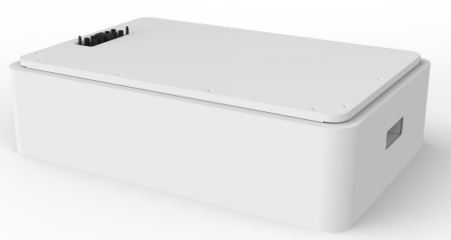
Control Box Module Front Interface | 100A | 1
Positive Cable to inverter | Red/25mm2  /L2000mm | 1 | 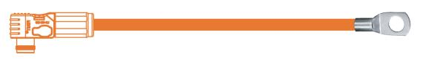
Negative Cable to inverter | Black/25mm2  /L2000mm | 1 | 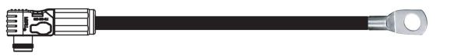
Communication Cable to inverter | L2000mm | 1
Ground Wire | L500mm/4mm2 | 1
User Manual |  | 1

3.2.Equipment installation

3.2.1、Installation Steps
Step 1 Mechanical Installation
- Brackets installation:
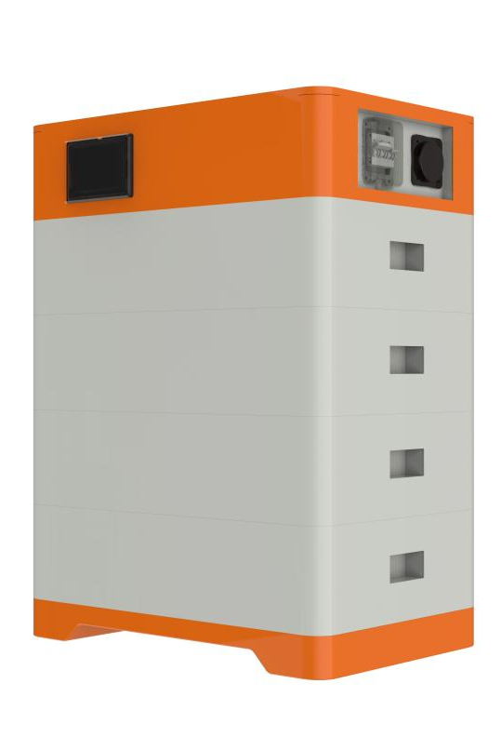
Step 1: Install the foundation
Step 2: Install the battery pack
Step 3: Install the Control Box Module
Step 2 Electrical installation
- Connect with inverter power lower than 5kw (including 5kw)
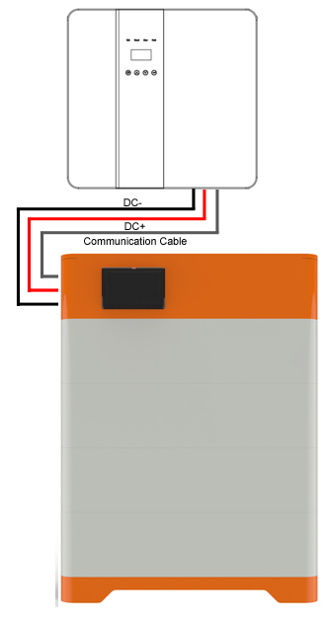

3.2.2 Battery parameter settings on the inverter
If your inverter do not have communication function with MSO51100 battery pack, please set inverter follow next data.

Max Charging(Bulk) Voltage: 57V*N
Absorption Voltage: 56.5V*N
Float Voltage: 56V*N
Shut Down(cut off) Voltage: 49V*N
Shut Down(cut off) SOC: 20%
Restart Voltage: 51.2V*N
Max Charge Current: 100A
Max Discharge Current: 100A

4.Installation and Configuration
4.1、Battery system usage and operation instructions
After completing the electrical installation, follow these steps to start the battery system.
1. Refer to the description of the DIP switch of 2.3.1 to prepare the battery module before
starting up, then press the ON/OFF button to the ON position.
2. After the indicator self-test, the RUN indicator will light and the SOC indicator will be on
(50% SOC status in the 2.3.4).

1. After pressing the power button, if the battery status indicator on the front panel continues to be red, please refer to the "4.2 Alarm description and processing ". If the failure cannot be eliminated, please contact the dealer timely.
2. Use a voltmeter to measure whether the voltage of the circuit breaker battery access
terminal is higher than48V, and check whether the voltage polarity is consistent with
the inverter input polarity. If the circuit breaker battery input terminal has a voltage
output and is greater than 48V, then the battery begun to work normally.
3. After confirming that the battery output voltage and polarity are correct, turn on the
inverter, close the circuit breaker.
4. Check if the indicator of the inverter and battery connection (communication indicator
and battery access status indicator) is normal. If it is normal, successfully complete the
connection between the battery and the inverter. If the indicator light is abnormal,
please refer to the inverter manual for the cause

4.2、Alarm description and processing
When protection mode is activated or system failure occurred, the alarm signal will be given
through the working status indicator on the front panel of the A48100. The network
management can query the specific alarm categories.
If the fault such as single cell over voltage, charging over-current, under-voltage protection,
high-temp protection and other abnormalities which affects the output, please deal with it
according to Table 4-1.
Table 4-1 Main alarm and Protection
Statue | Alarm category | Alarm indication | Processing
Charge state | Over-current | RED | Stop charging and find out the cause of the trouble
Charge state | High temp | Red | Stop charging
Discharge state | Over-current | Red | Stop discharging and find out the cause of the trouble
Discharge state | High temp | Red | Stop discharging and find out the cause of the trouble
Discharge state | Total voltage  undervoltage | Red | Start charging
Discharge state | Cell voltage undervoltage | Red | Start charging

4.3、Analysis and treatment of common faults
Analysis and treatment of common faults in the Table 4-2:
Table 4-2 Analysis and treatment of common faults
No. | Fault phenomenon | Reason analysis | Solution
1 | The indicator does not respond after the power on Total voltage lower than 40V Check the total voltage | Total voltage lower than 40V | Check the total voltage
2 | No DC output | Battery data status is abnormal.  Battery gets into over-discharged  protection | Read the battery  information on the  monitor.
3 | The DC power supply  time is too short | Battery capacity become smaller | Storage battery  replacement or add more modules
4 | The battery can't be  fully charged to 100% | Charging voltage is too low | Adjust charging voltage at 57V
5 | The power cable  sparks once power on  and ALM light RED | Power connection short-circuit | Turn off the battery, check the cause of the short circuit
6 | Communication fault | The DIP setting of the host is  wrong/ the battery type of the  inverter is wrong/  Communication cable used  incorrectly/The communication  cable is incorrectly connected at the battery communication port or the inverter communication  port/The battery firmware  version is too low to support the inverter | Check these possible  causes one by one
If you need any technical help or have any question, please contact the dealer in time.



This manual is for reference only, if the technology is better, please contact the distributor or our company.

